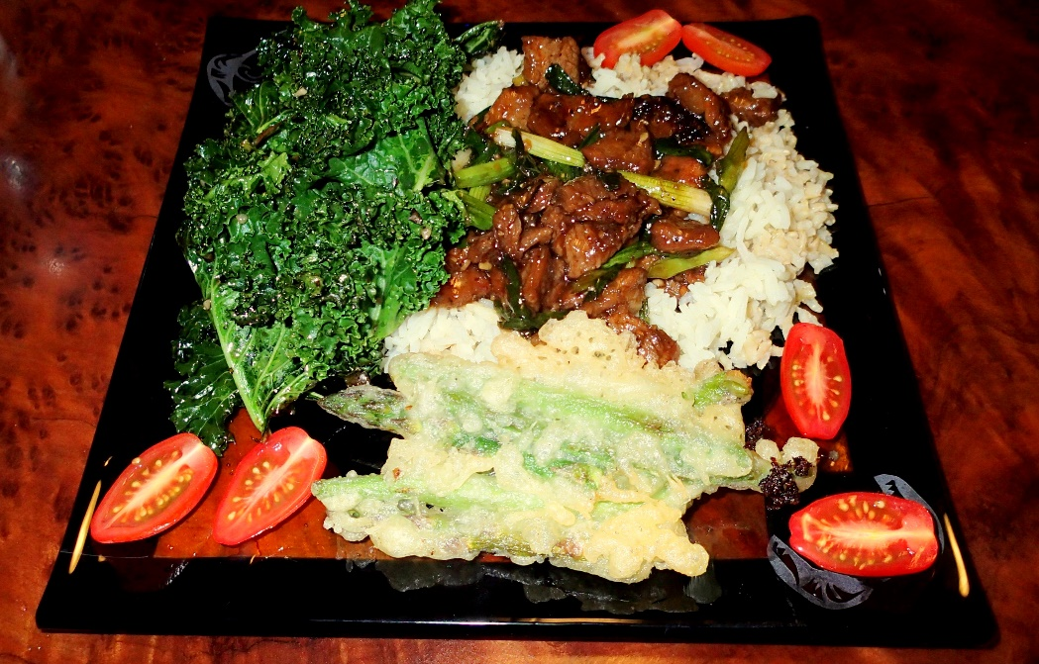

Mongolian Meat
Recipe by RHAK Founding Member Steve Stidham

2 teaspoons vegetable oil
1/2 teaspoon ginger, minced
1 tablespoon garlic, chopped
1/2 cup soy sauce
1/2 cup water
3/4 cup dark brown sugar
vegetable oil, for frying (about 1 cup)
1 lb Game steak
1/4 cup cornstarch
2 large green onions, sliced on the diagonal into one-inch lengths
Directions:
Make the sauce by heating 2 tsp of vegetable oil in a medium saucepan over med/low heat. Don't get the oil too hot. Add ginger and garlic to the pan and quickly add the soy sauce and water before the garlic scorches. Dissolve the brown sugar in the sauce, then raise the heat to about medium and boil the sauce for 2-3 minutes or until the sauce thickens. Remove it from the heat.

Slice the meat against the grain into 1/4" thick bite-size slices Dip the steak pieces into the cornstarch to apply a very thin dusting to both sides of each piece of meat. Let the meat sit for about 15 minutes so that the cornstarch sticks. As the meat sits, heat up one cup of oil in a non-stick pan. Heat the oil over medium heat until it's nice and hot, but not smoking.

Add the meat to the oil and sauté for just two minutes, or until the meat just begins to darken on the edges. You don't need a thorough cooking here since the meat is going to go back on the heat later. Stir the meat around a little so that it cooks evenly. After a couple minutes, use a large slotted spoon to take the meat out and onto paper towels, then pour the oil out of the wok or skillet.

Put the pan back over the heat, dump the meat back into it and simmer for one minute. Add the sauce, cook for one minute while stirring, add all the green onions. Cook for one more minute, remove the meat and onions with tongs or a slotted spoon to a serving plate.
Serve over fresh rice, topped with sesame seeds and chopped green onions.

